 | HIPPO  Foundation | De Verwondering 27  3823 HA Amersfoort  Nederland (Pays-Bas)  KvK 31049905 | tel/fax +31.33.4553623  hippomp@net.hcc.nl  www.hipponet.nl  Postbank 7862921

LOW-LIFT IRRIGATION PUMPS

HIPPO

♦Energy efficiency ♦Cost efficiency ♦Organizational efficacy

Mission: to promote the availability of affordable high-efficiency irrigation pumps. The focus is on the low-lift pumping conditions that prevail in small-scale irrigation along major Sahelian rivers, such as the Niger in Mali, West Africa. The HIPPO Foundation is a registered charity and is privately funded.
Main activities:
HariGoumo | Collaborating with the local pump rental initiative Hari Goumo ("low-cost water") in Timbuktu, Mali, to carry out low-cost field studies on affordable, low-lift pumping;
InfoService | Collecting, processing and exchanging technical, economic, commercial information on low-lift affordable irrigation pumping and related subjects;
Perspectives | Publishing reports on action-research supported or encouraged by HIPPO and on its cause in the e-bulletin "HIPPO Perspectives";
PumpSelect | Developing a framework for optimizing the selection of water-lifting equipment and establishing a database on pumpsets and related equipment (hoses, foot valves). See: http://www.hipponet.nl/ressources/pumpselect.xls
Opportunities | Helping develop funding and research opportunities in the field of affordable, small-scale, low-lift irrigation development in sub-Saharan Africa.

Main Achievements:
- Development of 2 databases on Asian pumps and engines
- Development of an Excel application to analyse pumpsets in terms of energy efficiency, fuel efficiency and pumping cost and with variables, such as speed, coupling system, appendages, pump and engine characteristics, pumping conditions, and crop water requirements.
- Development of a training course to transfer knowledge on Asian pump selection to government officials, project engineers, importers (used in Mali, Niger and Burkina)
- Identification, procurement and field testing in Mali of 5 inch pumpset (Kirloskar TV-1/NW9ME from India (see report below; test now in its 4th year). Results are promising.
- Identification, procurement and laboratory testing 4 inch pumpset (Changfa 170F/Wuxi 4HBC-35) (report underway, provisional report available). To be tested in the field (Mali) from 2003 onward. Results are promising.
- Identification of several 6 and 8 inch pumps from India and China. Awaiting final choice of what we expect to be the most suitable one. This choice is very difficult. HIPPO Foundation cannot afford to chose the wrong one.

Future Prospects:
- We intend to identify the best 6 or 8 inch pumpset soon to start field tests directly without prior laboratory tests in the Netherlands. This requires a visit to China, which is planned for late 2002 or early 2003. Our guess is that a 6-inch pumpset will satisfy farmer needs best (no v-belt, lighter than 8-inch, lower price compensates for slightly lower efficiency at very low static heads)
- Once this test evolves well (to be judged after 1 season), attempts will be made to send for 3-5 more in order to reduce risk of incidental failure and provide a platform for launching the pump rental operation using a loan.
- Simultaneously we expect to be able to identify a suitable channel for importing equipment. Various channels have been identified so far (the Chinese have quite a presence in West Africa!)
- The same channel will be open to farmers who wish to buy equipment instead of renting it. A hire-purchase arrangement will be offered, too.
- Once sufficient affordable equipment reaches the farmers, the attention of the HIPPO Foundation will shift to water efficiency in staple crops, such as rice, wheat and maize.

Main products (some can be downloaded from www.hipponet.nl, others are available via e-mail at hippomp@net.hcc.nl ):

Arby, D. (1998) Systèmes de Location de Groupes Motopompes dans la Vallée du Fleuve Niger dans la Région de Tombouctou au Nord du Mali.
Arby, D. and Van ‘t Hof, S. (2000) . Evaluation d'une motopompe Kirloskar TV-1/NW9ME à Kakondji, Tombouctou, Mali (www.hipponet.nl/ressources/kirloskar.htm)
Arby, D. (2001 Location et location-vente de groupes motopompes : créneau nouveau pour la promotion de l’irrigation privée dans la Région de Tombouctou, Mali. Journées d'Irrigation, Ouagadougou, Burkina Faso, 23-26 April, 2001.
Bom, G.J. and Van Steenbergen, F. (1997) Fuel efficiency and inefficiency in private tubewell development
Mr. Arby of Hari Goumo, the main partner of the HIPPO Foundation.
Van ‘t Hof, S. (2002a) Supporting irrigation networking in West and Central Africa: the establishment of ARID-L
Van ‘t Hof, S. and Maurice, L. (2002b) Efficiency, cost, optimization and spread of spray irrigation in West Africa
Van ’t Hof, S. (2002c) Fuel consumption report WM D1-22/4HBC-35 (test 15/06/02)
Van ‘t Hof, S. (2001a) Selection and procurement of efficient and affordable equipment from Asia for small-scale irrigation development in West and Central Africa
Van ‘t Hof, S. (2001b) Roving course on pump selection in Burkina Faso, Mali and Niger: lessons learned. Journées d'Irrigation, Ouagadougou, Burkina Faso, 23-26 April, 2001.
Van ’t Hof, S. (2001c) Turning ARID-L into a best practice network on small-scale irrigation: creating a sense of purpose
Van ’t Hof, S. (2001d) Formation sur le choix de motopompes: APIPAC (Burkina Faso) et ANPIP (Niger).
Van ‘t Hof, S. (2001e) Supporting market-led importation of small-scale irrigation equipment in West and Central Africa. Journées d'Irrigation, Ouagadougou, Burkina Faso, 23-26 April, 2001.
Van ’t Hof, S. (2000a) Affordable low-lift pumping for small-scale irrigation development : appropriate equipment selection
Van ‘t Hof, S. (2000b) Mission de définition des tests visant la réduction des coûts de pompage. BIRD/IDA/PDIAIM
Van ’t Hof, S. (2000c) Pompage à Basse Pression pour le Développement de la Petite Irrigation: sélection de matériels adaptés.
Van ’t Hof, S. (2000d) Dossier 1-12: (1) Kirloskar; (2) Flygt; (3) Vopo; (4) Stork (Johnson); (5) accessoires; (6) Standart; (7) pompes axiales; (8) Pancar; (9) moteurs chinois; (10) pompes artisanales; (11) pompes chinoises; (12) Rovatti/Caprari.
Van ‘t Hof, S. (2000e) PumpSelect: une application Excel pour l'évaluation technico-économique de motopompes.
Van ’t Hof, S., (1998) The design of a low-lift irrigation pump pilot project: improving the availability of affordable pumpsets to African farmers
Van ‘t Hof, S. (1997) HIPPO Perspectives nr. 2 : (1) advocacy of a HIPPO project ; (2) constraints to the proliferation of community-based irrigation; (3) possible intervention models ; (4) outline of a pump rental operation (also available in French).
Van ’t Hof, S. (1997) HIPPO Perspectives nr. 1 : (1) the objectives of the HIPPO Foundation ; (2) working hypotheses ; (3) current strategy ; (4) the initiators ; (5) HIPPO, the acronum and the emblem ; (6) historical overview of village irrigation in the region of Timbuktu (also available in French)
Van ‘t Hof, S. (1994) Economical low-lift pumps for village irrigation along the Niger River
Van ‘t Hof, S. (1992) Irrigation d’appoint à Bourem
Van ‘t Hof, S. (1991) Dépouillement provisoire offertes GMPs FENU
Very interesting are also: ANPIP (2000) Banc d'essais motopompes. (Auteurs: Abric, S., Bom, G.J., Lacas, J.G., Oumarou, H.); and: Perlack, R.D. et al. (1988) A comparison of decentralized minigrids and dispersed diesels for irrigation pumping in Sahelian Africa

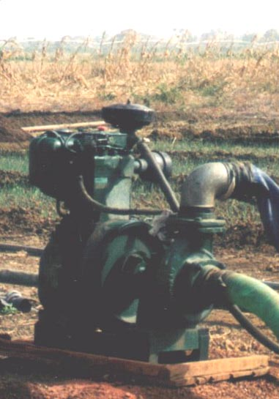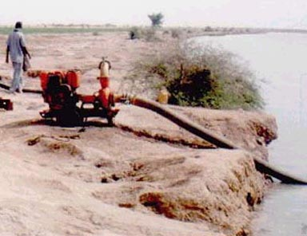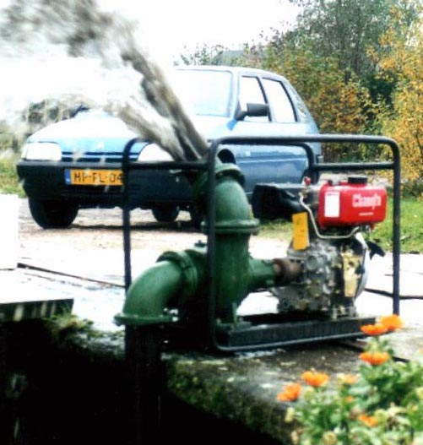
Kirloskar TV-1/”NW9ME” Low-lift pumping conditions along Niger River Wuxi 4HBC-35 with Yanmar look-alike
Typical low-lift pumping conditions

